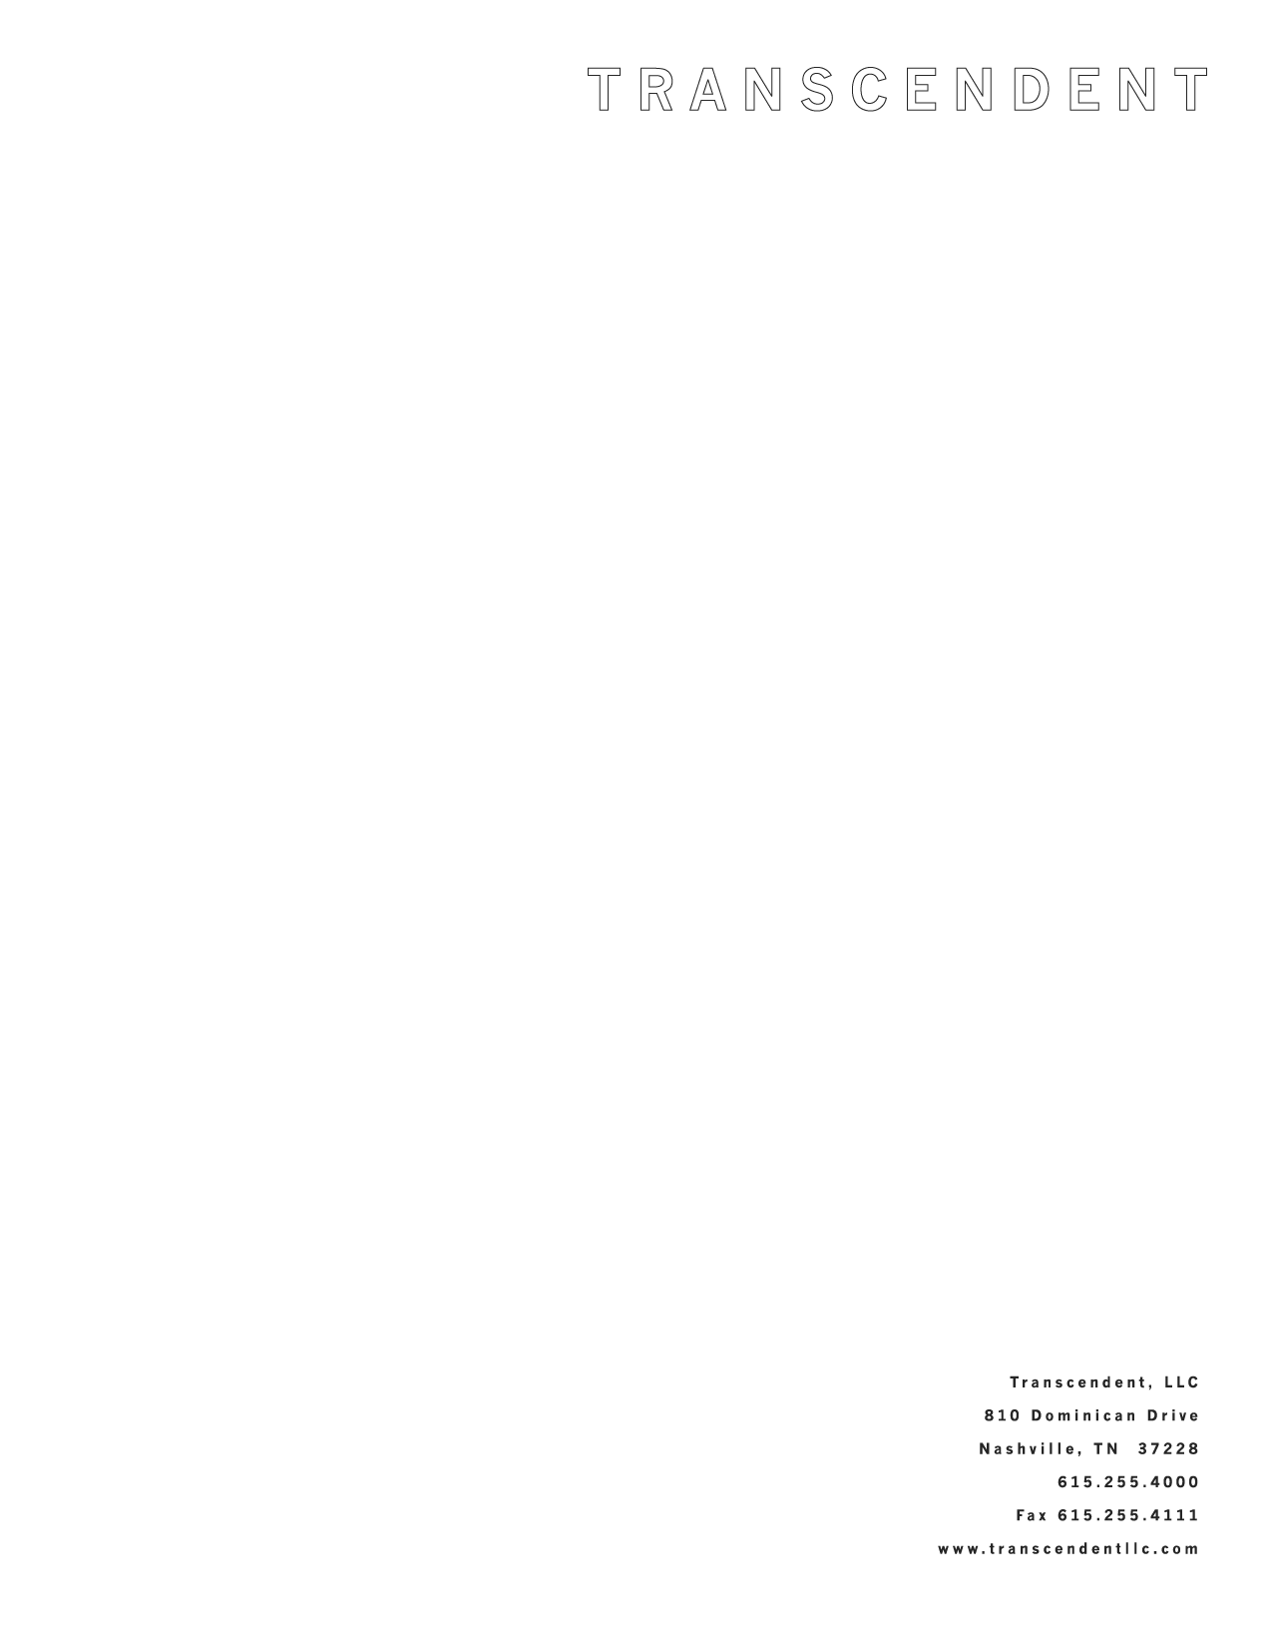

Nashville Feature Film Starring Sally Field to Open Here First
“Two Weeks” to be released theatrically March 2

Nashville, February 19, 2007 – Transcendent, the Nashville film company started by Film House owner Curt Hahn, announced today that “Two Weeks”, the independent feature film it co-produced with Steve Stockman’s Los Angeles-based Custom Productions, will be released theatrically by MGM in eight major markets nationwide including Nashville on March 2, 2007. The film, a bittersweet comedy starring Two Time Academy Award Winner Sally Field, was written and directed by Stockman. It was shot almost entirely in Nashville and will open locally at the Regal Green Hills 16, Regal Opry Mills 20 and Carmike Thoroughbred 20 in Cool Springs.

“Two Weeks" also stars Ben Chaplin (Thin Red Line, The Truth About Cats and Dogs), Tom Cavanagh (TV’s Ed, Scrubs, How to Eat Fried Worms), Julianne Nicholson (Flannel Pajamas, Law & Order: Criminal Intent, Kinsey), Glenn Howerton (It’s Always Sunny in Philadelphia, E.R.) and Clea Duvall (Heroes, The Grudge) and revolves around four siblings who rush home to say goodbye to their sick mother (Field) only to see her hang on, trapping them together for two weeks.
“As with most major studio theatrical releases, ‘Two Weeks’ will open in cities like New York and Los Angeles,” said Transcendent founder and Film House CEO Curt Hahn. “But because the film was shot in Nashville and co-produced by a local company, we were able to convince MGM to open ‘Two Weeks’ here as well. We hope the Nashville community will take advantage of this opportunity to see the film before most of the rest of the country.”

- more -

“Two Weeks” to Open Here March 2 Page 2

“We were warmly welcomed when we came to Nashville to film ‘Two Weeks’, and really enjoyed working with Transcendent and the terrific Nashville crews,” said the film’s writer-director Steve Stockman. “We loved making the movie here and we hope Nashville will love seeing it!”

Sally Field is the winner of two Academy Awards for Best Actress (for Norma Rae and Places in the Heart), currently stars in ABC’s hit series Brothers and Sisters and has created some of the screen’s most memorable women in such classic movies as Steel Magnolias, Mrs. Doubtfire and Forrest Gump. “Two Weeks” marks her first appearance in an independent feature film.

Two Weeks website, including electronic press kit: www.TwoWeeksMovie.com

About Transcendent
Transcendent, LLC (www.transcendentllc.com) produces high quality independent features. Drawing on the resources of parent company Film House (www.filmhouse.com), Tennessee’s largest production company, Transcendent’s goal is to produce the kind of inspiring, uplifting films that are often seen as too small for Hollywood; meaningful stories that speak to the viewer’s heart.

# # #

Contact:

J.P. Peach
Film House, Inc.
810 Dominican Drive
Nashville, TN 37228
615-255-4000
jppeach@filmhouse.com

